Assignment 1
Distributed systems
Sprencz Róbert

In this assignment our task was to implement two backend microservices to manage users and devices, and a frontend microservice to handle user interaction.

Conceptual architecture
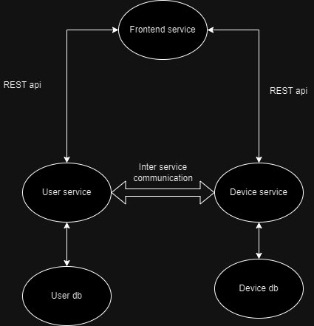
In this diagram we see a simple high level approach to this problem.
We have two backend microservices, each having their own database attached to them. There is also a bridge between the two microservices hich we will discuss in the deployment section.
In order for the frontend microservice to communicate with the backend microservices we have a RESTful api, on which they communicate with HTTP.

The user service
The user service is also tasked with handling authentification and authorization. More is discussed in the security section.
Deployment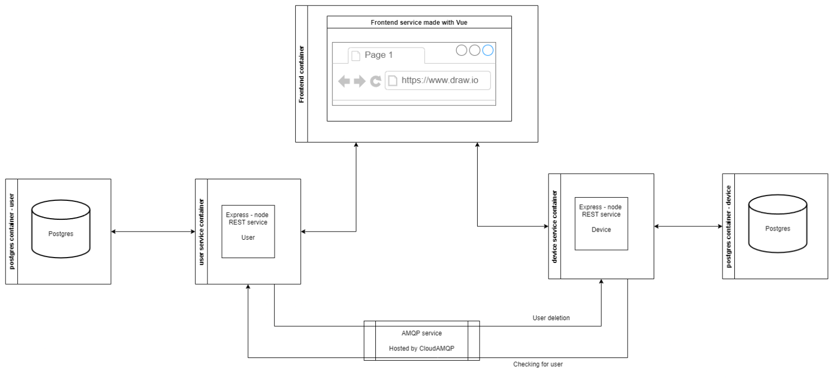
In order to deploy our microservices, I have used Docker containerization. Each microservice and database runs in a separate container, totaling 5 containers. Communication between these containers are handled for the most part by docker network.
The only special communication is between the two backend microservices. For this I used CloudAMQP. This is a message queue service hosted online. In order to connect to this service, we have a host/username and a password provided by them.
The databases are Postgres, with containers pulled from the Docker repository.
The frontend service is made with Vue and the backend services are made with NodeJS with Express to implement the REST api.

Build and execution considerations
Docker caching brings the benefit of faster subsequent builds . Another minor benefit of docker is the ability to easily track each container and see their status.
In order to run the application yourself, refer to the readme.md doc in the source code.

Security
Security was also taken into account. In order to handle login, we used JWT, with the jose library.
If the frontend does not have the cookie set, the Vue router will redirect to a ’403’ page. Without the cookie, our backend microservices don’t return anything and they also take into consideration the role of the user who makes the request.
The passwords are hashed in the databases using sha256.

